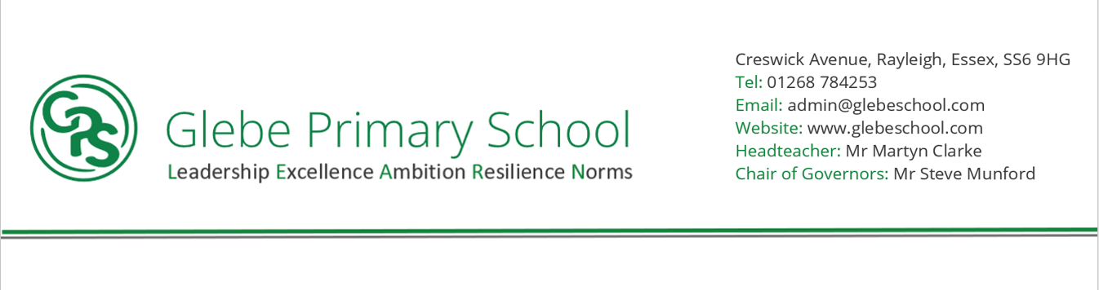

Statement of intent

At Glebe Primary School and Nursery, our curriculum is knowledge rich with our values of: Leadership, Excellence, Ambition, Resilience and Norms underpinning and enhancing the culture of our learning. Our pupils are brave, curious and respectful who take pride in achieving exceptional outcomes. Their thirst for learning is exemplified through their ability to make links between, and build upon, prior learning. They have an unrelenting passion for knowledge and support each other with compassion, kindness and an overall sense of belonging to our community. We aim for them to have a depth of understanding across the curriculum by broadening horizons and improving their life chances. Life-long learning habits form the foundation on which our curriculum is built. We achieve this by creating a culture of every subject that is learnt, exposing pupils to real life opportunities and concepts; exposing them to wide ranging and knowledge specific vocabulary.

At Glebe Primary School, we grow the next generation of Scientists, Historians, Mathematicians and more. We believe that within our community lives the next Doctor Maggie Aderin-Pocock; Tom Daly or JK Rowling!

**NORMS (Culture)**

**HIGH QUALITY OUTCOMES FOR ALL (from Day 1)/ - SUBJECTS ARE A CULTURE**

Consistently implemented systems; embracing the protected characteristics – A mentally healthy school;

A culture of TPP (Compassion, Kindness, connection, belonging, Hope); positive relationships between staff, pupils and parents; Development of character; Inclusion and adaptation regardless of disability or disadvantage - Demonstrate an understanding of the rights of others through kind, positive and respectful behaviour. Demonstrate a thirst for knowledge. Uphold British Values.

Understand and respect their fundamental rights as a child as outlined in UN conventions rights of the child.



**What have we found out?**

**LEADERSHIP**

Inspire others - Risk taking – Innovative- Good communicators- Motivating- Reflective -Taking responsibility- Perseverance- Individuality- Problem solving skills Delegation- Self-worth/confidence- Independence- Self-assurance- Negotiation strategies- Showing respect-Inspire others

**RESILIENCE**

Confidence in their abilities

Persevere in challenging situations

Mental health- resilience

Understanding a range of emotions and coping strategies

Sound understanding of how to improve well-being

Coping with adversity/ failures

Developing reciprocal friendships skills such as negotiation/compromise

Standing up for what you believe in

Learning from mistakes- not being afraid to make mistakes

Accepting constructive criticism

Risk taking

Out of comfort zone

**EXCELLENCE**

Secondary School ready

Mastery of basic skills to access the specialists in KS3/4

Outstanding attitudes, manners and curious about everything

Willing to question ideas and challenge stereotypes

97%-100% attendance

Pride in appearance/work/deportment

Key knowledge for interpersonal relationships, study skills, tolerance, taking their place in the world

Reciprocal communicators

Always willing to challenge themselves

**AMBITION**

Understanding of skills needed to achieve ambition

Bigger world view- exposed to new ideas- have no limits

Recognising that ambition is more than a job

Playing to strengths but recognising for themselves areas to develop

Recognising the need for resilience and to develop confidence in order to be the best they can be- small steps.

Not willing to coast- desire to challenge themselves

Hard work pays off- don’t be afraid of hard work.

No need to pull someone down in order to raise yourself up

Celebrate and encourage others