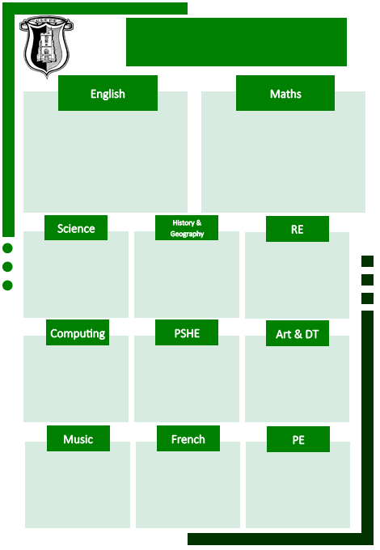

Shape – identify and describe the properties of 2D and 3D shape.

Measurement (Money) Recognise and use notation for pounds and pence. Find different combinations of coins to make the same amount.

Multiplication and division- recall and use multiplication facts for the 2, 5 and 10 times tables. Calculate mathematical statements for multiplication and division.

Exploring Feelings Through Music

Year 2 Music Festival Songs

Texts: The Enormous Crocodile, Revolting Rhymes (Little Red Riding Hood)- Roald Dahl Handa’s Hen

Atlas of Animal Adventures

Mama Miti- Wangari Maathai and the Trees of Kenya

Writing Genres: Information Text, Traditional Stories, Instructions, Character Description

Striking and Fielding Games (Taught by SSP coaches)

Net and wall games (Teacher taught)

Petit Chaperon Rouge (Little Red Riding Hood)

Sculpture and 3D- Clay houses

Money and Work

Growing and changing

Spreadsheets

Effective Searching

How do Jewish people celebrate Passover?

On Safari- A study of the human and physical geography of Kenya

Living Things and Their Habitats- Food Chains

Everyday Materials- Squash, Bend, Stretch and Twist

Curriculum map

Year 2 Spring Term