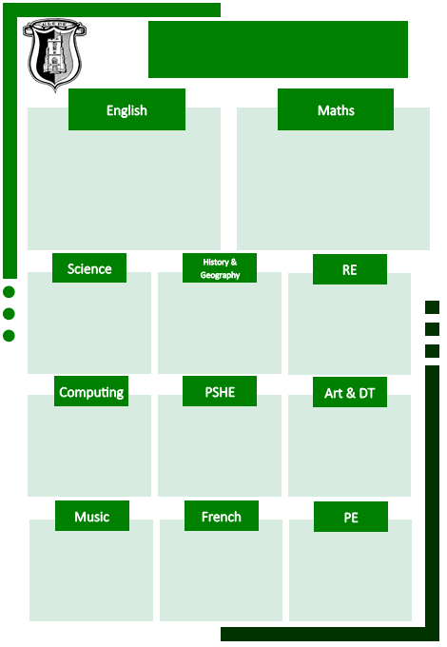

Does religion bring peace, conflict or both?

Christianity/ Hinduism/ Islam

What does it mean to be human? Is being happy the greatest purpose in life?

Humanist/ Christian

Charanga Music Scheme

Modern Fiction – Historical Setting (*When the Sky Falls by Phil Earle*)

Narrative writing (action focus)

Recount – Newspaper – Linked to WW2

Narrative writing (dialogue focus)

Explanation text

Poetry: Cinquains

Fractions – equivalent fractions, comparing and ordering, adding, subtracting, multiplying and dividing fractions

Converting Measures – metric and imperial

Ratio - – the link between ratio and fractions, scaling problems

Algebra – expressions, formulae, equations

Fractions, decimals and Percentages – making links and calculating with these

Area, Perimeter and Volume – area of a triangle, area of a parallelogram, calculating volume

Statistics – read and interpret pie charts, mean

Athletrics

Tennis

Hockey

Rounders

À l’école (At School)

Cooking and Nutrition

Painting and Mixed Media – Artist Study

How can we keep healthy as we grow?

How can the media influence people?

Online Safety

Blogging

Text Adventures

Networks

Geography – Map Work

History – World War Two (The Battle of Britain)

Local History (Rayleigh)

Animals Including Humans – The Art of Being Human

Light – Crime Lab Investigation

Curriculum Map

Year 6 Spring Term