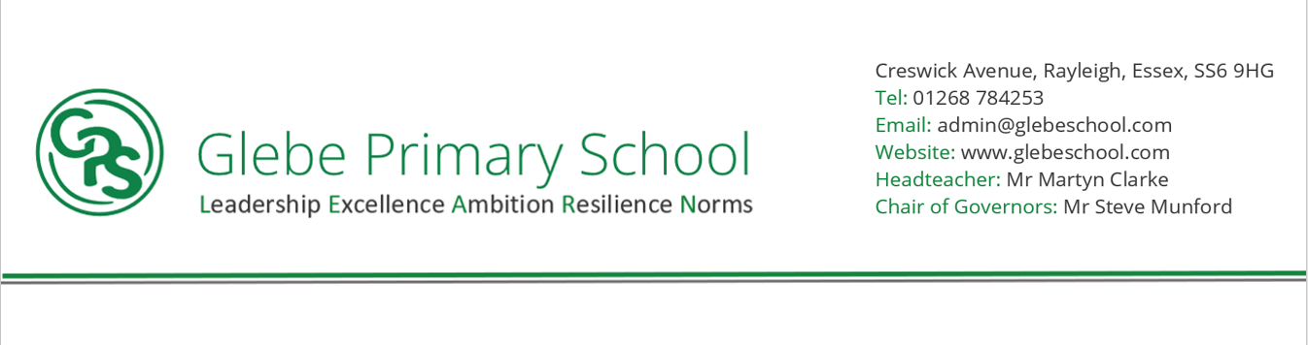

Statement of intent

At Glebe Primary School and Nursery, our curriculum is knowledge rich with our values of: Leadership, Excellence, Ambition, Resilience and Norms underpinning and enhancing the culture of our learning. Our intent for Science is to provide our students with an awe and wonder of the world around them. Science is a vital subject that promotes the acquisition of knowledge, curiosity, and enquiry skills. We aim to inspire, engage and excite students with hands-on experiments, investigative explorations, and observations that stimulate their senses and imagination. Our intent is to enable students to learn about the world by asking questions, researching, hypothesising, experimenting, and evaluating their findings. By doing so, we nurture our students' natural ability to be inquisitive and develop analytical and logical reasoning. Our Science curriculum is well balanced, coherent, and progressively sequenced, providing students with a solid foundation of scientific knowledge, vocabulary, and skills across the primary years.

**NORMS (Culture)**

**HIGH QUALITY OUTCOMES FOR ALL (from Day 1)/ - SUBJECTS ARE A CULTURE**

Our Science curriculum is implemented by a team of teachers who are passionate about inspiring and motivating children. We follow a balanced and sequential curriculum that incorporates knowledge, skills, and enquiry-based learning. Our lessons are carefully planned and differentiated to meet the needs of all learners, including SEND and EAL students. Our approach to teaching Science is exploratory and creative, providing opportunities for experimenting, investigating, and evaluating hypotheses. Teachers use a variety of resources, including technology, scientific equipment, and outdoor learning to enhance their lessons. Our assessment of Science is regular and ongoing, informing teachers of student's prior knowledge, misconceptions, and progress. This ensures that teachers adapt their planning and teaching to the individual needs of their students.



**What have we found out?**

**LEADERSHIP**

Take risks **-** Be reflective **–** Persevere **-** Be independent learners **-** Show respect towards others and their work **-** Inspire others

**RESILIENCE**

* Children to gain confidence in their own abilities
* Opportunities given for children to take part in practical science and use their problem-solving skills in their lessons.
* Children encouraged to take risks, try new approach.
* Children learning from their mistakes.
* Children learn to work as a team and that they need to be tolerant of others when working together.

**EXCELLENCE**

* Teaching and Learning
* Develop outstanding attitudes about Science
* Curiosity about Science
* Opportunities to experience a range of activities in Science
* Pupil Knowledge of Scientists
* Pupil knowledge of how scientific developments impact our everyday life.
* Long-term memory of knowledge and vocabulary
* An ambitious and outstanding curriculum design that starts from EYFS
* Expectation for all to have access to a broad and balanced curriculum

**AMBITION**

* Children given opportunities to see science in action, learn from people who work in a scientific field
* Children will learn how science is changing our lives all the time and the everyday impact these changes have on our lives.
* Children encouraged to reflect on their own strengths and realise for themselves areas they need to develop
* Breadth and Depth of curriculum prepares all pupils for next steps in their learning journey and early insights into their careers.