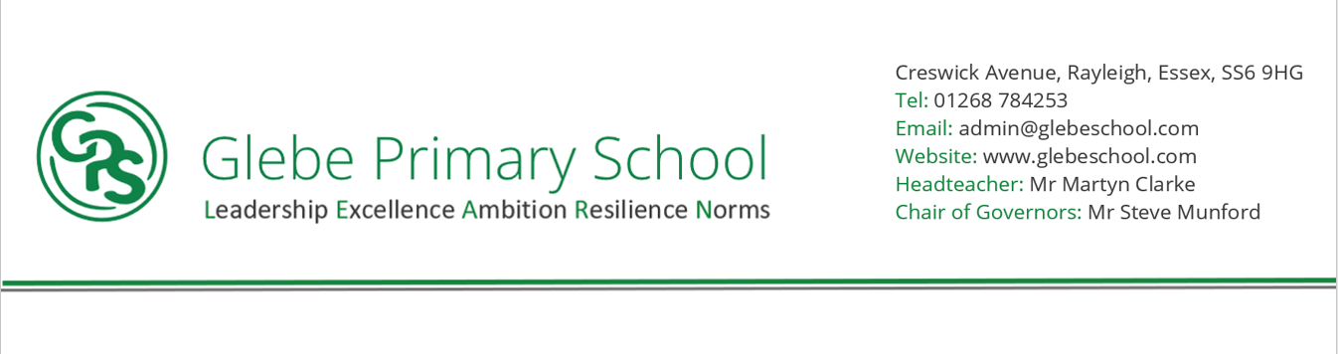

Statement of intent

Through our English curriculum we aim to promote high standards of language and literacy by equipping pupils with a strong command of the spoken and written word and to develop their love of literature through widespread reading for enjoyment.

We have a rigorous and well organised English curriculum that provides many purposeful opportunities for reading, writing and discussion. Our curriculum closely follows the aims of the National Curriculum for English 2014 to enable all children to: read easily, fluently and with good understanding; develop the habit of reading widely and often for both pleasure and information; acquire a wide vocabulary, an understanding of grammar and knowledge of linguistic conventions for reading, writing and spoken language; write clearly, accurately and coherently, adapting their language and style in and for a range of contexts, purposes and audiences; use discussion in order to learn; they should be able to elaborate and explain clearly their understanding and ideas; are competent in the arts of speaking and listening, making formal presentations, demonstrating to others and participating in debate.

These aims are embedded across our literacy lessons and the wider curriculum. We will provide the means for children to develop a secure knowledge-base in Literacy, which follows a clear pathway of progression as they advance through the primary curriculum. Rigorous assessment and review will ensure that we are able to provide targeted support so that all children experience success in literacy; we believe that a secure basis in literacy skills is crucial to a high-quality education and will give our children the tools they need to participate fully as a member of society

**NORMS (Culture)**

**HIGH QUALITY OUTCOMES FOR ALL (from Day 1)/ - SUBJECTS ARE A CULTURE**

Reading becomes a natural, embedded element of the school day, not something that is bolted on ‘if we have time’. Pupils have time and space (where possible in classrooms) dedicated to reading throughout the week. Reading is an exciting thing to do that pupils look forward to doing – it is not seen as a ‘chore’, but something that pupils actively engage in.



**What have we found out?**

**LEADERSHIP**

Pupils work together either in pairs, small groups, or even across year groups to help each other develop a love for reading, but also to model good reading. Adults throughout the school model good reading and engage pupils with a range of strategies, for example, choral reading and echo reading.

**RESILIENCE**

* Pupils are prepared to challenge themselves in their reading material, but work out for themselves what is an ‘appropriate’ level of challenge for them individually
* Pupils are not afraid to mis-read or misunderstand. They are prepared to ask questions to secure their understanding

**EXCELLENCE**

**In Reading**

* Phonics taught daily with rigour and consistency in lower school
* Pupils supported to gain speedy decoding and recognition of unfamiliar words
* Pupils are quickly identified as needing extra phonic support in all year groups and systems in place to help them ’catch up’.
* Providing appropriate reading material to match a pupil’s phonic stage.
* Pupils are assessed half termly to monitor both comprehension and fluency
* Pupils provided with a wide diet of quality reading material through a reading spine.
* Pupils have quality texts read to them, texts they may not be able to access individually, but expose them to a wide-range of vocabulary and different ‘world views’
* Reading material in Glebe reflects the diverse nature of the world we live in, encouraging pupils to think beyond their own life experiences

**AMBITION**

* Pupils throughout the school leave Glebe as fluent readers
* Pupils are able to draw on knowledge they have acquired through studying a broad range of subjects and from being exposed to a wide range of books and make links to seemingly unrelated topics
* Pupils express a genuine desire and passion for reading, both to acquire knowledge and just for pleasure
* Pupils become active readers, not just passive listeners
* Pupils want to ‘get better’ at reading for their own sake, not just because adults tell them it’s a good thing