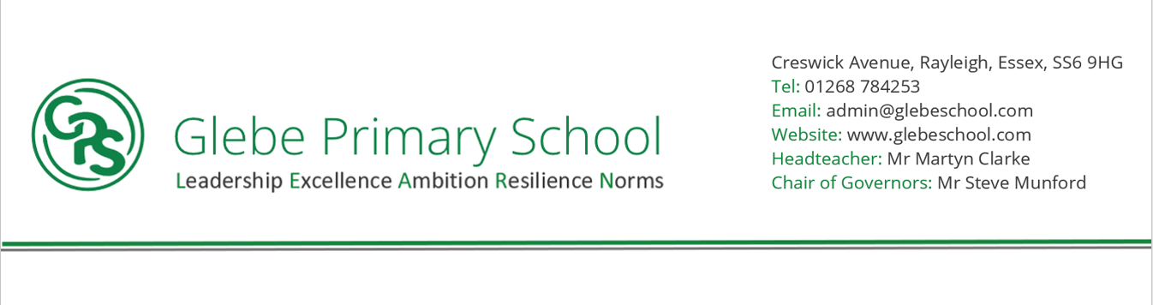

Statement of intent

At Glebe Primary School, we want to ensure children have a lifelong love of music and **inspire** children to develop their talents as musicians, and increase their **self-confidence**, **creativity**, **teamwork** and **sense of achievement**. We believe all children should perform, listen to, review, and evaluate music, be taught to sing, create, and compose music and understand and explore how music is created, produced, and communicated.

At Glebe Primary the intention in Music is that children gain a firm understanding of music through **listening, singing, playing,** **evaluating, analysing**, and **composing** across a wide variety of historical periods, styles, traditions, and musical genres. We intend to provide a knowledge rich Music curriculum in line with the National Curriculum and ensure the progressive development of musical concepts and skills.

The Charanga scheme of work is used from EYFS to Year 6 to ensure a wide exposure to different genres of music, with lots of practical opportunities to explore and develop as musicians and singers. The aims of our music curriculum are to develop pupils who:

* Can sing and use their voices to create different effects.
* Enjoy and have an appreciation for music
* Listen to, review and evaluate music across a range of historical periods, genres, cultures, styles and traditions.
* Create and compose music both on their own and with others
* Use and understand a range of musical language
* Make judgements and express personal preferences about the quality and style of music.
* Take part in performances with an awareness of audience.

**NORMS (Culture)**

**HIGH QUALITY OUTCOMES FOR ALL (from Day 1)/ - SUBJECTS ARE A CULTURE**

Pupils will show respect for other cultures and locations and seek to expand their knowledge of the world. Pupils will recognise and celebrate diverse cultures, peoples and places and understand how it connects and relates to their own culture and country. Pupils will have a greater knowledge of the world and their place in it.



**What have we found out?**

**LEADERSHIP**

Pupil will be encouraged to stay positive all times - Pupils will learn to always find a way to solve problems - Pupils will learn to accept positive feedback and learn from criticism - Pupils will be resilient and persevere, becoming good communicators while developing their problem-solving skills -Pupils will show respect to others, admit their mistakes and be good listeners.

**RESILIENCE**

**At Glebe Primary School we want all pupils:**

* To develop a ‘can do’ attitude
* To keep on going and persisting when challenges occur
* To consolidate prior learning and gradually learn new skills, knowledge, concepts and language.
* To concentrate on achieving something important to them

**EXCELLENCE**

**At Glebe Primary School all pupils will:**

* Access an engaging and fun musical curriculum
* Develop a secure knowledge and understanding of music through singing, listening, performing, composing and musicality.
* Explicitly be taught a progressive development of musical concepts, knowledge, language and skills.
* Understand and explore how music is created, produced, and communicated, including through the interrelated dimensions: pitch, duration, dynamics, tempo, timbre, texture, structure and appropriate musical notations
* Perform, listen to, review and evaluate music across a range of historical periods, genres, styles and traditions, including the works of the great composers and musicians

**AMBITION**

**At Glebe Primary School we want our children to love Music!**

We want them to be able to:

* Sing and use their voices individually and in a group
* Create and compose music on their own and with others
* Use technology appropriately when composing
* Have opportunities to learn a musical instrument
* Understand and explore how music is created, produced and communicated
* Listen to, review, and evaluate the work of great composers and musicians from a range of historical periods, genres, styles and traditions
* Enjoy and have an appreciation of a range of different musical styles e.g. Classical, Jazz, Hip Hop, Pop, Rock etc.
* Use and understand musical language and include musical features in their own work
* Make judgements about the quality of music
* Have opportunities to play a wide variety of instruments
* Have different opportunities to take part in performances