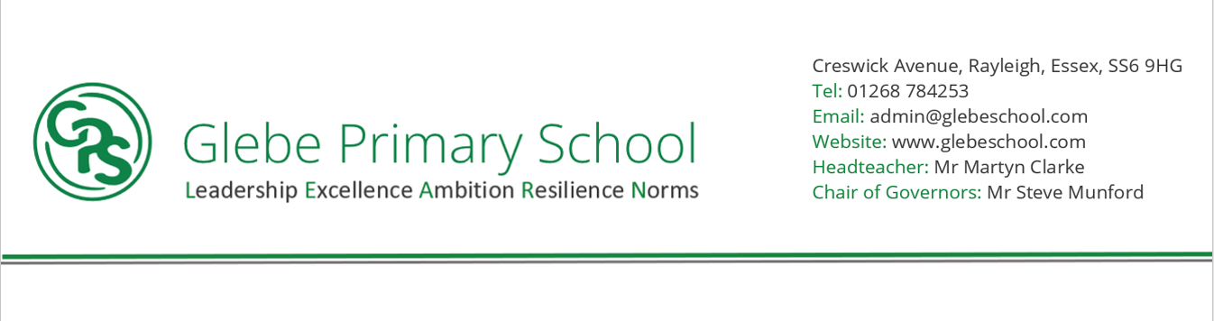

Statement of intent

At Glebe Primary, our intention in Geography is to provide all pupils with a secure knowledge of the world around them through investigative thinking. We want pupils to have the knowledge, understanding, confidence, attitudes, and values they need in order to reach their potential as individuals applying geography to their local community and the wider world. Our aim is to promote a curiosity and interest of the world around them, to encourage children to become responsible, global citizens and provide them with skills and knowledge to navigate and explore. This is taught through the National Curriculum and is broken down into 4 strands: Locational knowledge, place knowledge, human and physical geography, geographical skills and field work.

Pupils will be taught to think about the world they live in and develop an appreciation for the diversity of our world and develop their knowledge about different places, people, resources and natural and human environments together with a greater understanding of the Earth’s key physical and human processes. Pupils’ knowledge about the world will help them to develop their understanding of the interaction between physical and human processes and of the formation and use of landscapes and environments. Pupils will be encouraged to gain confidence and enjoy practical experiences through local fieldwork studies and in the wider community. Our intention is to create confident geographers who can use and apply their key geographical skills, including the gathering and analysis of data information.

Through the curriculum, pupils will be encouraged to think, ask questions and to discover their answers to their own questions through exploration and research to enable them to gain a greater understanding and knowledge of the world and their place in it.

**NORMS (Culture)**

**HIGH QUALITY OUTCOMES FOR ALL (from Day 1)/ - SUBJECTS ARE A CULTURE**

Pupils will show respect for other cultures and locations and seek to expand their knowledge of the world. Pupils will recognise and celebrate diverse cultures, peoples and places and understand how it connects and relates to their own culture and country. Pupils will have a greater knowledge of the world and their place in it.



**What have we found out?**

**LEADERSHIP**

Pupil will be encouraged to take risks and think differently and innovate becoming independent learners. Pupils will reflect and learn from their own knowledge and skills. Pupils will be resilient and persevere, becoming good communicators while developing their problem-solving skills. Pupils will show respect to other cultures and others.

**RESILIENCE**

Pupils to gain confidence in their own abilities and to not be afraid to learn from errors or mistakes

Pupils to become independent resilient learners

Pupils to learn from constructive criticism

Pupils encouraged to learn to take risks and use different strategies or ways of thinking

Pupils to become problem solvers and gain perseverance when solving problems

**EXCELLENCE**

Pupils will have an interest and curiosity regarding other countries and their people

Pupils will gain geographical skills and knowledge

Pupils to have opportunities to experience geographical field work and exploration

Pupil Knowledge of explorers and geographers

Long-term memory of knowledge and vocabulary

Expectation for all to have access to a broad and balanced geography curriculum with local and international locations.

**AMBITION**

Pupils given opportunities to explore local and worldwide cultures and countries

Pupils encouraged to reflect on their own strengths and realise for themselves areas they need to develop

Pupils to be aware of different ways they can apply their geographical skills

Pupils to celebrate and encourage their own understanding and skills

Pupils to have high aspirations and goals to prepare them for the next steps in their learning journey and into future careers