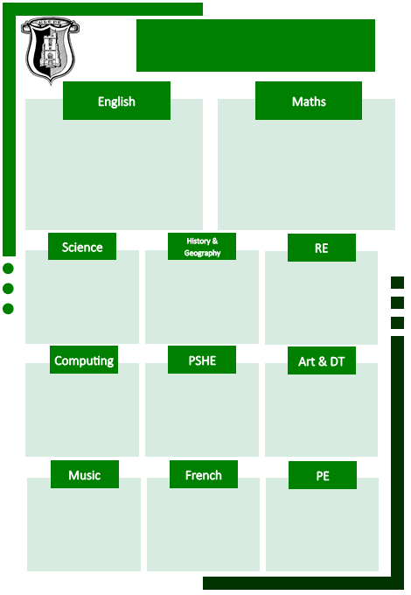

Charanga Music Scheme

Stories with familiar settings: *Gorilla* by Anthony Browne.

Recount (diary as Guy Fawkes) *Mr Fawkes, the King and the Gunpowder Plot* and *Remember, Remember the Fifth of November*.

Fiction - Different stories by the same author: *Lost and Found* and *How to Catch a Star* by Oliver Jeffers

Non-Chronological Report- Penguins

Shape Poetry

Place Value – including: recognising tens and ones, partitioning two digit numbers and using a place value chart.

Numbers to 100 – including: count in 2s, 3s, 5s, and 10s.

Addition and Subtraction – including: number bonds and fact families to 20, strategies to add and subtract within 100, solve missing number problems and worded problems.

Shape – 2D and 3D shape.

Gymnastics (Taught by SSP coaches)

Ball skills (Teacher taught)

Dance (Taught by SSP coaches)

Fundamental skills

(Teacher taught)

Dans Ma Ville – in My Town

Mixed Media – life in Colour

Structures with Moving Parts

Belonging to a Community

Respecting Ourselves and Others

Coding

Spreadsheets

Why is light an important symbol for Christians, Jews and Hindus?

What does the Nativity Story teach us about Jesus?

The Gunpowder Plot

Robert Falcon Scott

Everyday materials

Living Things and Their Habitats

Curriculum map

Year 2 Autumn Term