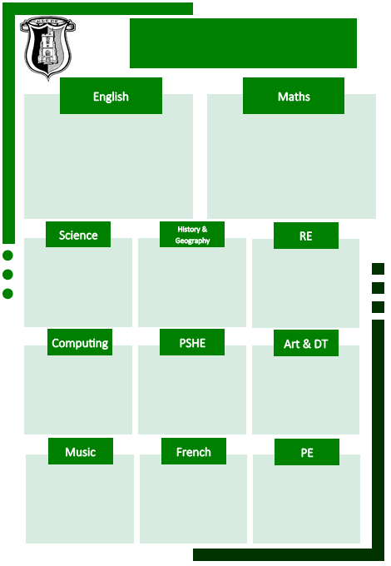

Charanga Music Scheme

Modern Fiction (*Holes* by Louis Sachar)

Recount (letter and diary) *linked to Holes*

Non-Chronological Report- Lizards

Free Verse Poetry

Classic Fiction: Oliver Twist by Charles Dickens and Street Child by Berlie Doherty

Narrative writing (historical setting)

Biography (Thomas Barnardo)

Classic Poetry

Place Value – including numbers to ten million

Addition, Subtraction, Multiplication and Division – factors, multiples, prime numbers, square numbers, short and long division, order of operations

Fractions – equivalent fractions, comparing and ordering, adding, subtracting, multiplying and dividing fractions

Converting Measures – metric and imperial

Gymnastics (Taught by SSP coaches)

Basketball (Teacher taught)

Dance (Taught by SSP coaches)

Les Vêtements (Clothes)

Drawing - Make My Voice Heard

Electrical Board Game

Keeping Healthy as We Grow

Coding

Online Safety

How do beliefs shape identity for Muslims?

Islam

Does religion bring peace, conflict or both?

Christianity/ Hinduism/ Islam

Geography – North America

History – The Victorians

Evolution and Inheritance – The Game of Survival

Electricity – Electric Celebrations

Curriculum Map

Year 6 Autumn Term