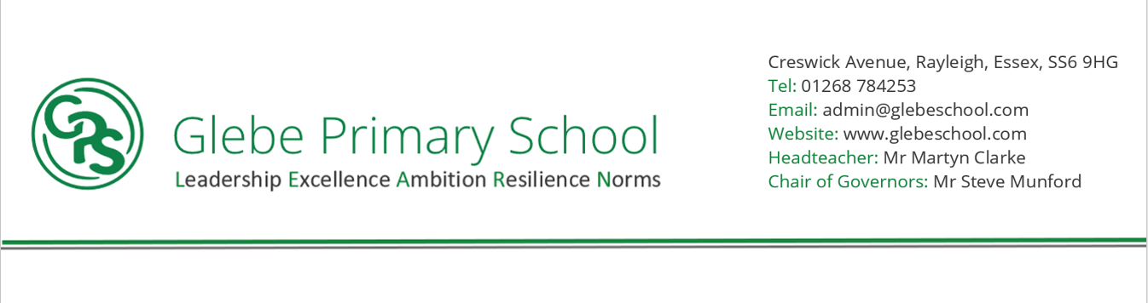

Statement of intent

At Glebe Primary School and Nursery, we aim to provide a knowledge rich curriculum for Art and Design that inspires and engages our pupils. The curriculum coverage is in line with the National Curriculum, and is delivered in a way that gives pupils a range of exciting opportunities to experience Art through being creative. Our Art and Design curriculum will enable all learners to progress in the concepts of**: Knowledge of artists and designers:** (factual knowledge), **Exploring and** **developing ideas**:(conceptual knowledge), **Making skills and Formal elements:**(procedural knowledge) and **Evaluating:** (metacognitive knowledge).

To help our pupils to become confident and competent artists and designers, we teach pupils the knowledge they require and give them opportunities to experience a range of different artists, designers and craftsmen. We intend for our pupils to develop a knowledge of practical, theoretical and disciplinary artistry where they gain a deeper understanding and more in-depth knowledge when recognising high quality works of art through differing medium; the ability to confidently articulate art and artists. We hope that pupils will learn to discuss, emulate and evolve as part of their own developing knowledge of art.

**NORMS (Culture)**

**HIGH QUALITY OUTCOMES FOR ALL (from Day 1)/ - SUBJECTS ARE A CULTURE**

Consistently implemented systems; embracing the protected characteristics – A mentally healthy school;

A culture of TPP (Compassion, Kindness, connection, belonging, Hope); positive relationships between staff, pupils and parents; Development of character; Inclusion and adaptation regardless of disability or disadvantage - Demonstrate an understanding of the rights of others through kind, positive and respectful behaviour. Demonstrate a thirst for knowledge. Uphold British Values.

Understand and respect their fundamental rights as a child as outlined in UN conventions rights of the child.



**What have we found out?**

**LEADERSHIP**

* Take risks, Be reflective, Persevere, Be independent learners, Show respect towards others and their work, Inspire others

**RESILIENCE**

* Children to gain confidence in their own abilities
* Opportunities given for children to receive feedback on their creations and be able to accept constructive criticism.
* Children encouraged to take risks, try new approaches in Art which are maybe out of their comfort zone.
* Children learning from their mistakes.

**EXCELLENCE**

* Teaching and Learning
* Outstanding attitudes about Art
* Curiosity about Art
* Opportunities to experience Art & Design
* Pupil Knowledge of Artists
* Long-term memory of knowledge and vocabulary
* Expectation for all to have access to a broad and balanced curriculum

**AMBITION**

* Children given opportunities to see art/Artists from the local and wider community
* Children given opportunities to celebrate their own artwork and encourage others too
* Children encouraged to reflect on their own strengths and realise for themselves areas they need to develop
* Breadth and Depth of curriculum prepares all pupils for next steps in their learning journey and early insights into their careers.