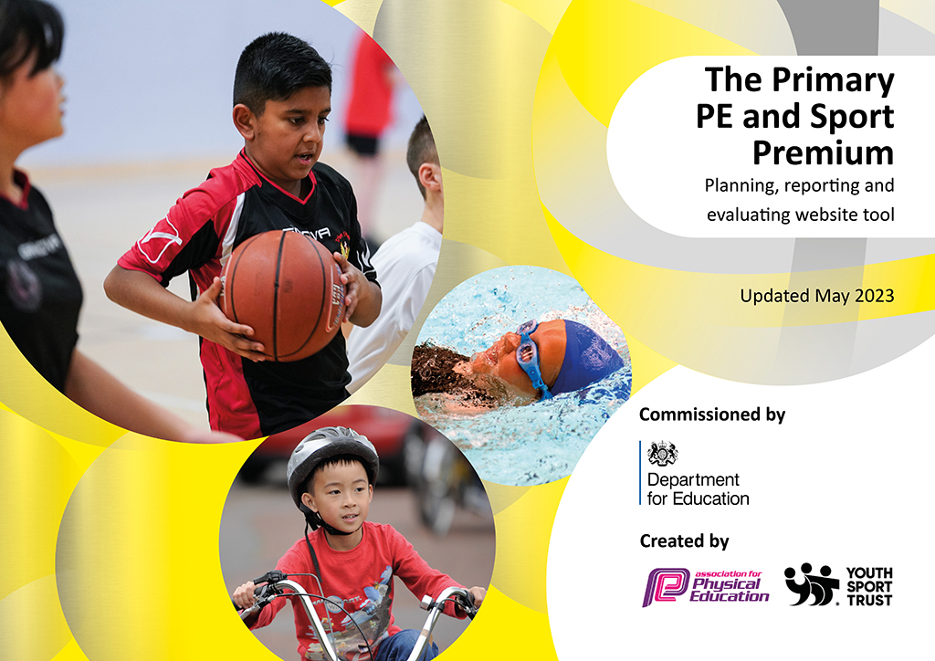
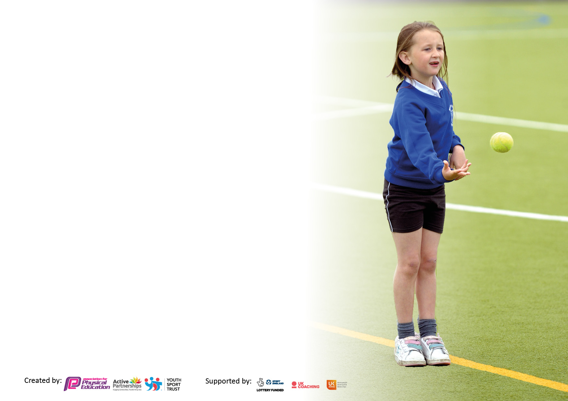

It is important that your grant is used effectively and based on school need. The Education Inspection Framework makes clear there will be a focus on ‘whether leaders and those responsible for governors all understand their respective roles and perform these in a way that enhances the effectiveness of the school’.

Under the Quality of Education Ofsted inspectors consider:
Intent - Curriculum design, coverage and appropriateness
Implementation - Curriculum delivery, Teaching (pedagogy) and Assessment
Impact - Attainment and progress

To assist schools with common transferable language this template has been developed to utilise the same three headings which should make your plans easily transferable between working documents.

Schools must use the funding to make additional and sustainable improvements to the quality of Physical Education, School Sport and Physical Activity (PESSPA) they offer. This means that you should use the Primary PE and sport premium to:

- Develop or add to the PESSPA activities that your school already offer
- Build capacity and capability within the school to ensure that improvements made now will benefit pupils joining the school in future years
- The Primary PE and sport premium should not be used to fund capital spend projects; the school’s budget should fund these.

Pleasevisitgov.ukfortherevisedDfEguidanceincludingthe5keyindicatorsacrosswhichschoolsshoulddemonstrate animprovement.Thisdocumentwillhelpyoutoreviewyourprovisionandtoreportyourspend.DfEencouragesschools to use this template as an effective way of meeting the reporting requirements of the Primary PE and Sport Premium.

We recommend you start by reflecting on the impact of current provision and reviewing the previous spend.

Schools are required to publish details of how they spend this funding, including any under-spend from 2021/2022, as well as on the impact it has on pupils’ PE and sport participation and attainment. All funding must be spent by 31st July 2023.

We recommend regularly updating the table and publishing it on your website throughout the year. This evidences your ongoing self-evaluation of how you are using the funding to secure maximum, sustainable impact. Final copy must be posted on your website by the end of the academic year and no later than the 31st July 2023. To see an example of how to complete the table please click HERE.

Details with regard to funding
Please complete the table below.

Total amount carried over from 2021/22 | £19,000
Total amount allocated for 2021/22 | £
How much (if any) do you intend to carry over from this total fund into 2022/23? | £
Total amount allocated for 2022/23 | £19,000
Total amount of funding for 2023. To be spent and reported on by 31st July 2023. | £ 19,000
Swimming Data
Please report on your Swimming Data below.

Meeting national curriculum requirements for swimming and water safety.  N.B. Complete this section to your best ability. For example you might have practised safe self-rescue techniques on dry land which you can then transfer to the pool when school swimming restarts.  Due to exceptional circumstances priority should be given to ensuring that pupils can perform safe self rescue even if they do not fully meet the first two requirements of the NC programme of study | Complete to the best of your ability – list here how you have gathered the information ( survey , lessons , parents etc)
What percentage of your current Year 6 cohort swim competently, confidently and proficiently over a distance of at least 25 metres?  N.B. Even though your pupils may swim in another year please report on their attainment on leaving primary school at the end of the summer term 2022.  Please see note above | 91%
What percentage of your current Year 6 cohort use a range of strokes effectively [for example, front crawl, backstroke and breaststroke]?  Please see note above | 82%
What percentage of your current Year 6 cohort perform safe self-rescue in different water-based situations? | 76%
Schools can choose to use the Primary PE and sport premium to provide additional provision for swimming but this must be for activity over and above the national curriculum requirements. Have you used it in this way? | Yes – As part of Castle Point and Rochford SSP we collectively contribute to a targeted Top Up Swimming holiday programme to support students to reach 25m. This is coordinated centrally by the SSP team.

Action Plan and Budget Tracking
Capture your intended annual spend against the 5 key indicators. Clarify the success criteria and evidence of impact that you intend to measure to evaluate for pupils today and for the future.

Academic Year: 2022/23 | Total fund allocated: | Date Updated:
Key indicator 1: The engagement of all pupils in regular physical activity – Chief Medical Officers guidelines recommend that primary school pupils undertake at least 30 minutes of physical activity a day in school |  |  |  | Percentage of total allocation:
 |  |  |  | %
Intent | Implementation |  | Impact
Your school focus should be clear what you want the pupils to know and be able to do and about  what they need to learn and to  consolidate through practice: | Make sure your actions to achieve are linked to your intentions: | Funding allocated: | Evidence of impact: what do pupils now know and what can they now do? What has changed?: | Sustainability and suggested next steps:
SSP ‘BASIC MEMBERSHIP MODEL – Physical And Health and Wellbeing strands ( see attached)  To impact on all students in Key Stage 1 and 2.  Please note some aspects are deliberately targeted at least active children.  To build regular physical activity into the school day for all students.  To provide a breadth of opportunities for pupils to be active daily including break , lunch and cross curricular activities.  To work with the wider school community and workforce through targeted CPD to ensure staff are competent and confident in implementing daily activity strategies.  To work with the SSP through events and festivals to inspire regular activity and provide a daily mile/activity strategy.  To utilise the Active School Planner tool to identify areas to improve the offer across the day for students to be active. | 1.Select group of children attended  3 x Active Kids festivals.  2. 3 x Multi skills virtual festival resources created and made available to all schools  3. Network of local (Level 2 competition) and regional (Level 3) sports competitions and other School Games opportunities. Coordination and delivery of the Bikeability programme  Premier education coaches and specialist SSP coaches provide skilled coaching – before and after school.  Access to the CPRSSP Gifted and talented programme of events.  MDA training for active playground. | Points 1, 2 and 3 are all funded through SSP Basic membership. £2000  Annual cost is divided equally across all 5 Key Objectives (£390)  £1500 | In the level 2 competitions that we took part in, we finished in the top three places in most of them. First place in dodgeball and basketball.  All pupils continued to have at least 2 hours of curriculum PE lessons each week.  Improved facilities on the ks2 playground allowed more children to be active at play and lunch times eg Table tennis, basketball etc | Attend future events and pass on active ideas to additional children.  Join outside school sports clubs in the local area.  Network of local and regional sports competitions and festivals
Key indicator 2: The profile of PESSPA being raised across the school as a tool for whole school improvement |  |  |  | Percentage of total allocation:
 |  |  |  | %
Intent | Implementation |  | Impact
Your school focus should be clear what you want the pupils to know and be able to do and about  what they need to learn and to  consolidate through practice: | Make sure your actions to achieve are linked to your intentions: | Funding allocated: | Evidence of impact: what do pupils now know and what can they now do? What has changed?: | Sustainability and suggested next steps:
SSP ‘BASIC MEMBERSHIP MODEL – all strands contribute to this area. To impact on all students and staff in Key Stage 1 and 2.  Creating pupil voice and enhancing status of PE and school sport.  To ensure training takes place to enable the school to facilitate active and productive break and lunch times.  To ensure all staff access PE specific CPD across the academic year to raise the profile and importance of the subject.  To provide development support for staff to raise the quality of PE and School Sport on offer which , in turn, will raise the profile of the subject.  Increasing capacity to engage pupils in intra-house competitions.  Year 6 children trained as PE monitors to get resources ready for lessons across the school. | 1. Attendance at PE Lead meetings and share outcomes across whole school.  2. Engage with Team Teaching opportunities through SSP projects, PALs, Flying Start and Fit4Action for teaching and support staff (Largely delivered in Autumn and summer terms)  Book 1 x termly staff inset PE specific sessions through the SSP based on internal staff needs to raise the profile of PE across all staff.  Pupil voice questionnaires used to support and deliver child-centred PE lessons.  The use of Twitter, school website and newsletter to raise the profile of P.E. and sports within the school and celebrate success.  Celebration Assembly used to raise the profile of PE and sports.  To collate photographs and sports reports for display on the School Games Board and digital information screens around the school. | Points 1-3 are all funded through SSP Basic membership. £2000  Annual cost is divided equally across all 5 Key Objectives (£450)  Lunch time organized sports activities.  £4945 | 1. Registers and staff attendance.  3. Staff planner allocating opportunities for each pupil to access at least one after/before school club.  Continued use of the school’s website and newsletter to raise the profile of sports, and inform the community of our involvement in festivals and competitions.  School sports noticeboard updated with photos and news from competitions and festivals attended.  Year 6 pupils trained as PE Monitors  Links with local clubs established and strengthened eg Rochford angling club, Rochford tennis and rugby clubs. | Regular PE feedback slot at staff meetings to share knowledge.  Develop an ethos of shared responsibility across PE, SS and Physical Activity.  Engage pupils in intra-house competitions.

Key indicator 3: Increased confidence, knowledge and skills of all staff in teaching PE and sport |  |  |  | Percentage of total allocation:
 |  |  |  | %
Intent | Implementation |  | Impact
Your school focus should be clear | Make sure your actions to | Funding | Evidence of impact: what do | Sustainability and suggested
what you want the pupils to know | achieve are linked to your | allocated: | pupils now know and what | next steps:
and be able to do and about | intentions: |  | can they now do? What has
what they need to learn and to |  |  | changed?:
consolidate through practice:
SSP ‘BASIC MEMBERSHIP MODEL – all strands contribute to this area (see attached) High Quality PE is most prominent. To impact on all students and staff in Key Stage 1 and 2.  To ensure that all staff are trained in a range of topics to deliver high quality PE sessions. To ensure students are able to actively participate in and contribute to high quality PE lessons. To ensure that students have a broad and detailed knowledge of a wide range of sporting activities by the end of KS 2.  To provide a high quality Differentiated scheme of work so that teachers will be able to follow and guide pupils without difiiculty.  To engage the use of specialist Sports coaches to team teach alongside teacher in specific areas of improvement.SUFC Primary Stars  To sign NQT and other children to attend PE courses to gain in confidence. | 1. Attendance at SSP PE Lead meetings to gain knowledge to share.  Employment of specialist dance teacher to raise profile of dance and share quality first teaching methods to impact all.  Deliver 3 x staff inset sessions based on staff audit of needs. Track impact.  SUFC staff, in conjunction with the Premier League, to deliver the Heart of the Community programme to the year 6 pupils.  Specialist SUFC coaches taught the Primary Stars programme (healthy living) alongside the year 5 teachers.  NQT booked to attend high quality PE teaching sessions led by SSP.  SSP led PE training in  Spring term. | Points 1 and 2 are all funded through SSP Basic membership. Annual cost is divided equally across all 5 Key Objectives (£390)  Dance teacher employment: 3,000  Specialist gym and dance teacher alongside NQT  £780 | Feedback given to enhance staff understanding of changes in PE and sport teaching. National priorities shared and demonstrated.  Timetable allowed all staff to benefit from the opportunity to enhance practice.  Staff Inset sessions took place in the Spring and Summer terms.  SUFC staff, in conjunction with the Premier League, successfully delivered the Move and Learn and Primary Stars programmes to the years 6 and 5 pupils.  Valuable experience and confidence gained by NQT in the delivery of indoor PE, especially in the teaching of gymnastics. | Develop scope and opportunity to lead whole school INSET meetings.  2. Allowing staff time to attend events and then share findings.
Key indicator 4: Broader experience of a range of sports and activities offered to all pupils |  |  |  | Percentage of total allocation:
Intent | Implementation |  | Impact
Your school focus should be clear | Make sure your actions to | Funding | Evidence of impact: what do | Sustainability and suggested
what you want the pupils to know | achieve are linked to your | allocated: | pupils now know and what | next steps:
and be able to do and about | intentions: |  | can they now do? What has
what they need to learn and to |  |  | changed?:
consolidate through practice:
SSP ‘BASIC MEMBERSHIP MODEL – all strands contribute to this area (see attached) School Sport is most prominent.  To impact on all students and staff in Key Stage 1 and 2  To ensure every child has the opportunity to represent the school in an external inter school competition, league or festival and be able to articulate how this made them feel.  To equip students by the end of KS 1 to enjoy a range of skills and activities to fully engage in active play and games  To support each individual child to find ‘their’ chosen sport or activity.  To utilise SSP expertise to deliver a wide range of clubs and coaching opportunities to our students.  To introduce new sports or other activities to encourage more pupils to take up sport and physical activities.  SUFC Premier Stars | Prepared children to access a broad range of Festivals, competitions and leagues.  Groups of children were entered in events aimed at less active students e.g. Multi Skills Festival, skipping festival, dance festivals, Key Stage 1 Winter Games etc  Different children took part in non-traditional sporting activities eg Angling, archery, darts etc.  Engage with Active Kids Festivals  Children enjoyed a range of Gifted and Talented holiday camps – different students access different sports and activities.  Resources purchased to allow all lessons to be of the highest quality and support clubs to fully engage pupils in a range of physical activity.  Free after/ before school clubs for ks1 and ks2 children.  Hearing Impaired pupils took part in the Paralympic festivals.  Links with local schools to provide opportunities for more children to take part in sporting events eg hockey at Sweyne Park; Cross Country at FitzWimarc; football at Wickford primary | Points 1-5 are all funded through SSP Basic membership. Annual cost is divided equally across all 5 Key Objectives (£390  Archery, darts etc with Premier Sports £ 1,826  £4000  Transport to competitions  £1250  Release time for teachers to attend sports events, training and competitions | Records of events entered, records of children and participation levels across school.  Completion of community club request sheet. Requests based on consulting students, records of need.  Allocation and timetable of breakfast, lunchtime and after school clubs.  Keep a record of letters, invited students and those who attended  Increased number of girls have joined local football clubs as a result of starting a girls football club.  Rochford Angling club have mentioned children from our school visiting the club as a result of the opportunity given to them. | A plan to ensure all students have termly opportunities to prepare, attend and represent school.  Tracking of students’ attendance and engagement in broader extra- curricular sport post event.  6. Link selections to performance in PE, School Sport and ensure students are correctly identified by engaging staff in the process.

Key indicator 5: Increased participation in competitive sport |  |  |  | Percentage of total allocation:
 |  |  |  | %
Intent | Implementation |  | Impact
Your school focus should be clear | Make sure your actions to | Funding | Evidence of impact: what do | Sustainability and suggested
what you want the pupils to know | achieve are linked to your | allocated: | pupils now know and what | next steps:
and be able to do and about | intentions: |  | can they now do? What has
what they need to learn and to |  |  | changed?:
consolidate through practice:
SSP ‘BASIC MEMBERSHIP MODEL  To identify a wide range of sporting festivals and sports for our school and students to participate in.  To ensure every child enjoys the experience of representing the school in a festival, league or competition (appropriate to their needs) and is able to articulate the learning taken from the experience.  To utilise whole school intra competition to raise standards across all subjects with PE and SS as the initial driver.  To understand and be able to deal with emotionally, both winning and losing in sport.  To organise B and C team events.  To provide transport so that children can attend sports events. | Increased number of children took part in a wide range of competitions and festivals organised by SSPs.  Children participated in SUFC organised competitions.  A number of competitive sporting events organised against other local schools eg hockey @Sweyne, Cross country @FitzWimarc, boys and girls football @Wickford.  3. Entry into Dance Festival  4. Development of intra (in school) competitive opportunities.  5. Ensuring students access Gifted and Talented holiday camps to support their development and pathway into community competitive sport and beyond  6. Coaches organised to ensure all pupils able to attend and remove barriers | Points 1-5 are all funded through SSP Basic membership  Annual cost is divided equally across all 5 Key Objectives (£400  Transport cost to festivals and competitions £1250  PE equipment replacement and sports day equipment.  £1600  Release time for teachers to attend sports events, training and competitions  £2000 | CPRSSP events attended including opportunities for children to perform on stage in the local theatre.  Finished in top three of most competitions this year.  Won the hockey and dodge ball competitions.  Intra school festivals embedded in the PE sessions once half-termly.  6. Over 150 children accessed sports competitions and performances in cross country and dance performances. | Annual calendar discussed and produced in consultation with headteacher.  Engagement of a wide range of teaching and support staff in fixtures, transport and training. Investment in kit.  Develop further intra competition into whole school diary.

Signed off by
Head Teacher:
Date:
Subject Leader:
Date:
Governor:
Date:

